For building indices: <https://www.researchgate.net/publication/269942632_Description_of_Welzel_Data_for_QoG_and_WVS_1_t_6_Key_Aggregates/link/549a6aba0cf2fedbc30cb5ff/download>

WVS Data Overview: in total 61 observations

* Created a dataframe with group 2 (WVS) observations only

1. **Q184 Satisfaction**

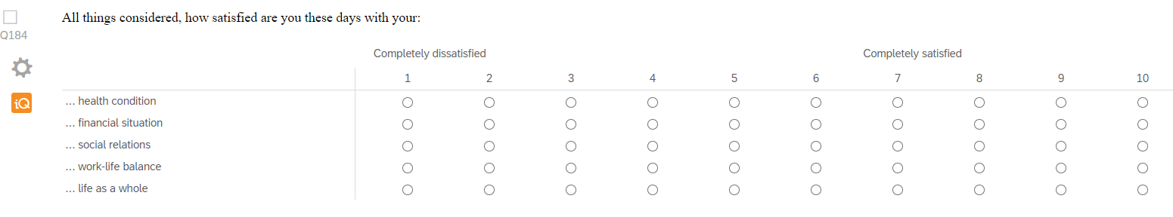

* MC options do not have a label since only 1: completely dissatisfied and 10: completely satisfied were specified
* 5 variables: sathealth_w1lg, satfinance_w1lg, satsocial_w1lg, satbalance_w1lg, satlife_w1lg

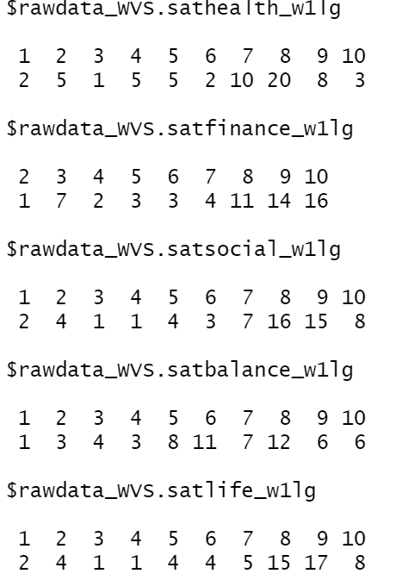

* No missing values
* Distributions within the variables:

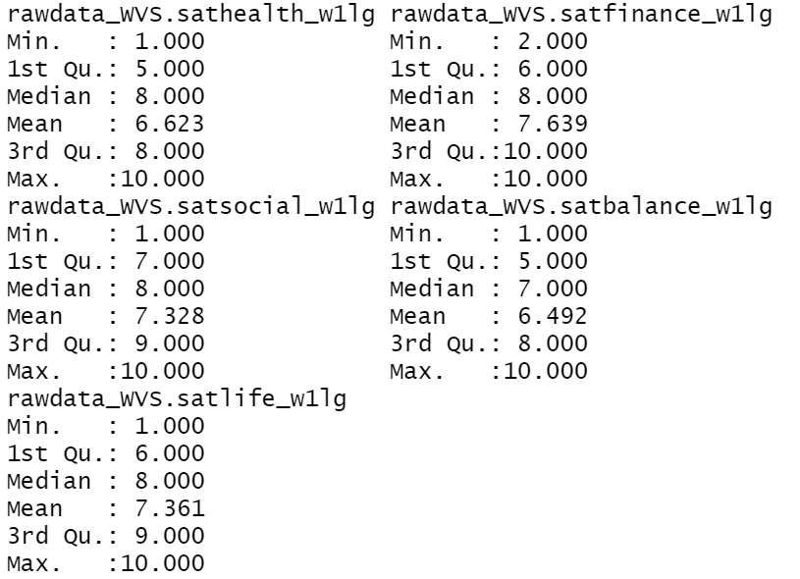 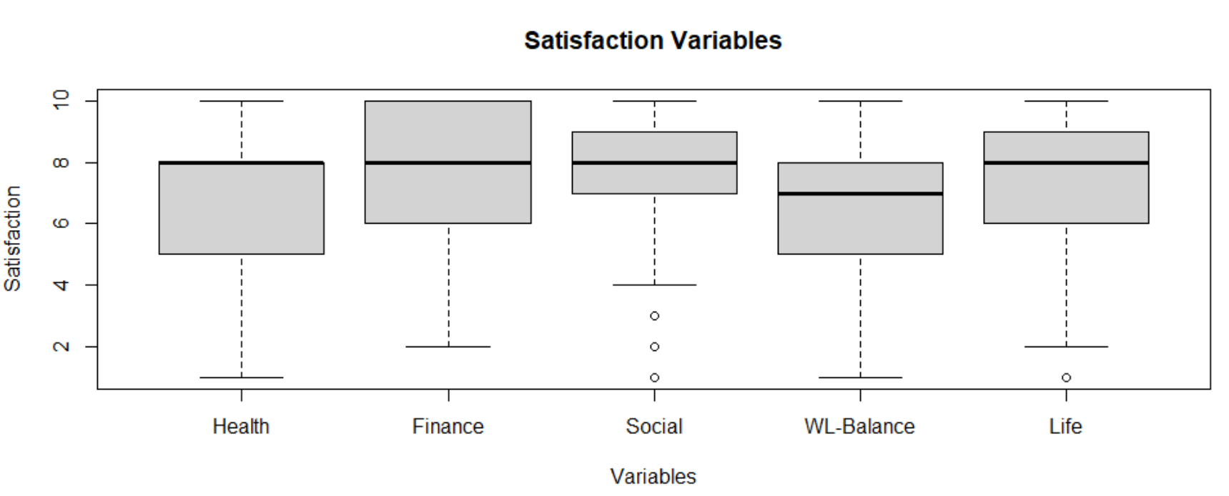

* Satisfaction index as mean of all satisfaction variables

 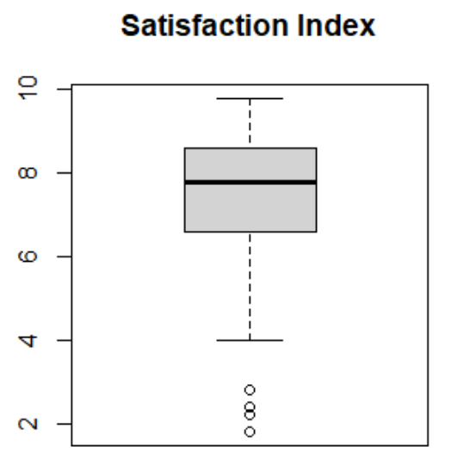

* + Currently the life as a whole variable is in there, I also considered taking it out
  + Could also group it into low, rather low, rather high, high based on the quartiles

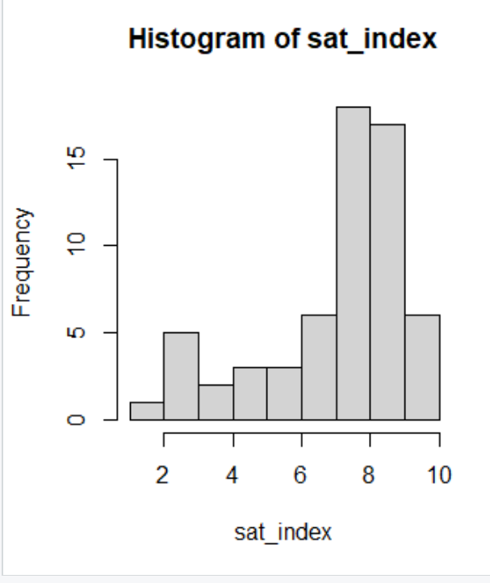

1. **Q38 Valued Qualities in Children:**

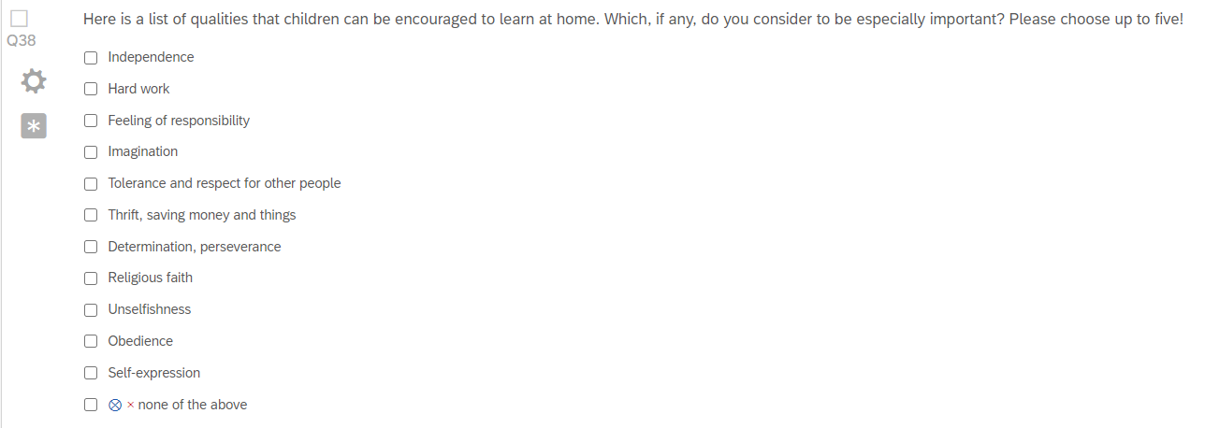

* qualitychild_w1lg: table shows frequencies of each combination of qualities

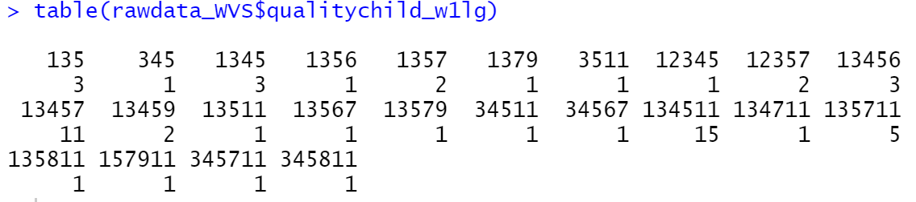

* no missing values
* Values need to be recoded:
  + 1: Independence
  + 2: Hard work
  + 3: Feeling of responsibility
  + 4: Imagination
  + 5: Tolerance and respect for other people
  + 6: Thrift, saving money and things
  + 7: Determination, perseverance
  + 8: Religious faith
  + 9: Unselfishness
  + 10: Obedience
  + 11: self-expression
  + 12: none of the above?
* I created a new variable/column for each of the values listed above stating whether this value was “mentioned” or “not mentioned” (basically that’s the way it’s also done in the WVS)
* The autonomy index =a computed variable based on the Children qualities battery): the idea is to add the positive answers of religious faith and obedience and substract the positive answers of independence and determination. Since mentioned=1 and not mentioned=2, the index will be -2 if both Religious faith and Obedience are mentioned but NOT Independence and Determination-Perseverance (+1+1-2-2=-2) and, on the other extreme +2 if both Independence #and Determination-Perseverance are mentioned but NOT Religious Faith and Obedience (-1-1+2+2=+2).

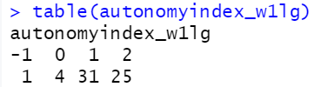

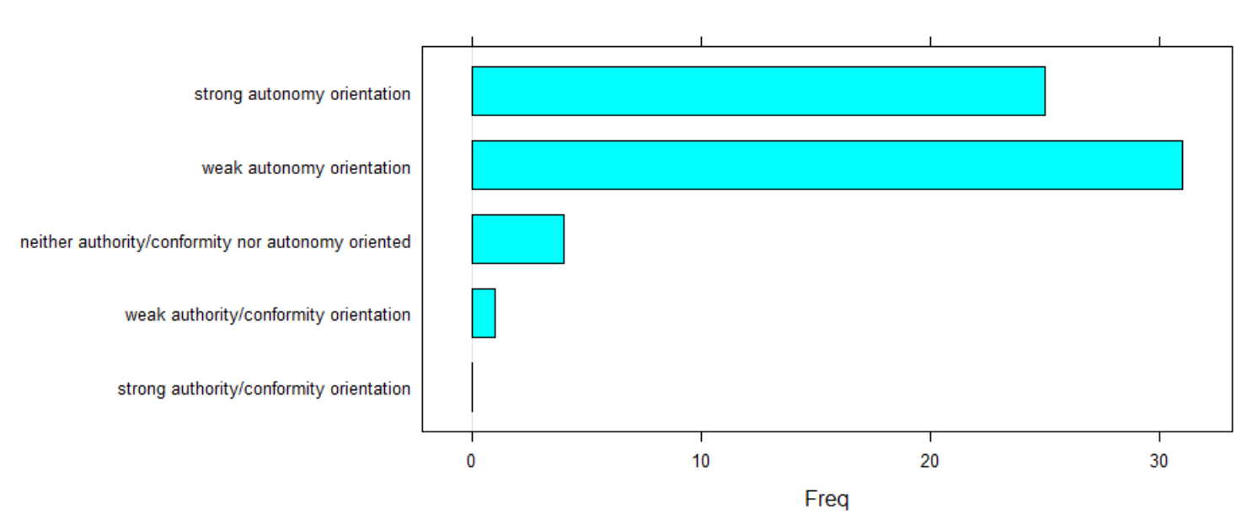

1. **Q40 trusting**

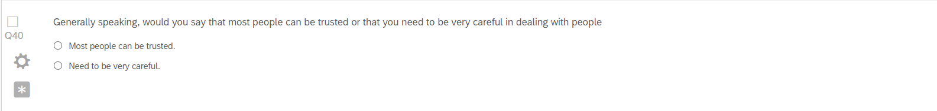

* trustpeople_w1lg

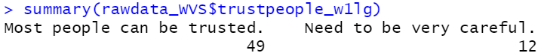

* no missing values

1. **Q44 gender statements I**

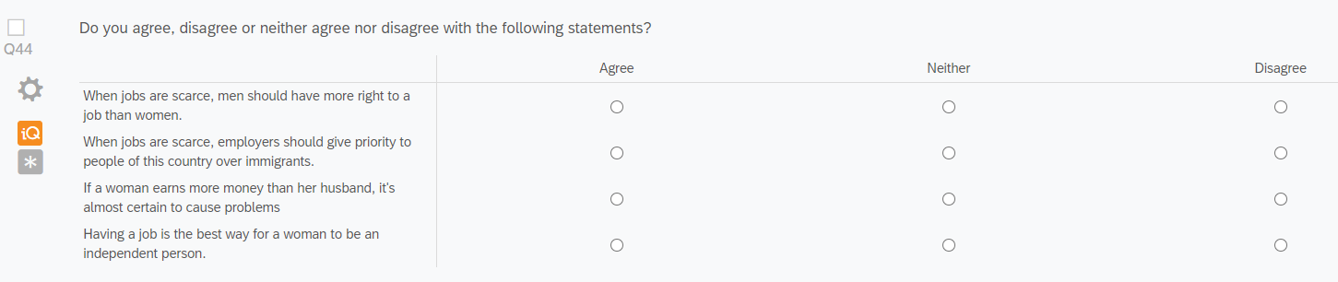

* 4 variables: jobsformen_w1lg, jobsfornationals_w1lg, richwomanproblem_w1lg, womanjobindependent_w1lg

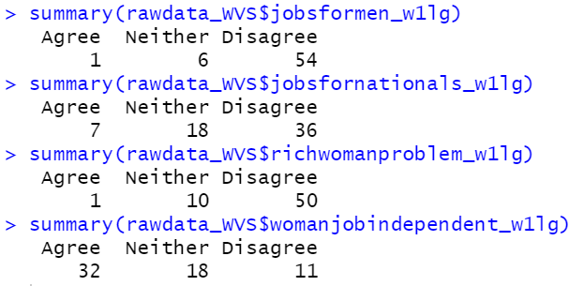

* No missing values
* Still to do: Indices have to be built

1. **Q45 Gender Statements II**

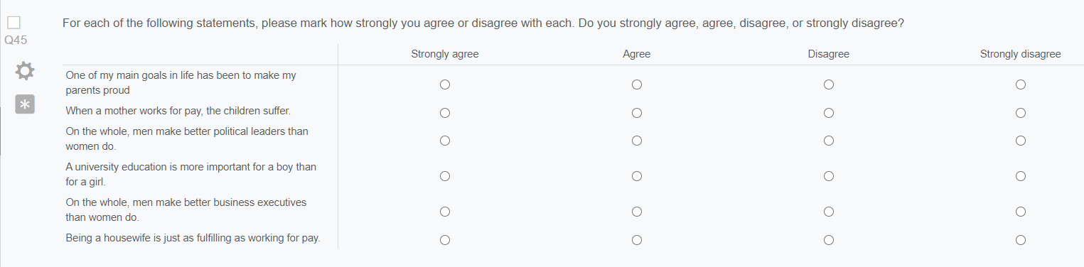

* 6 variables: Lifegoalparents_w1lg, momworkingbad_w1lg, menbetterpoliticians_w1lg, uniformen_w1lg, menbetterbusiness_w1lg, happyhousewife_w1lg

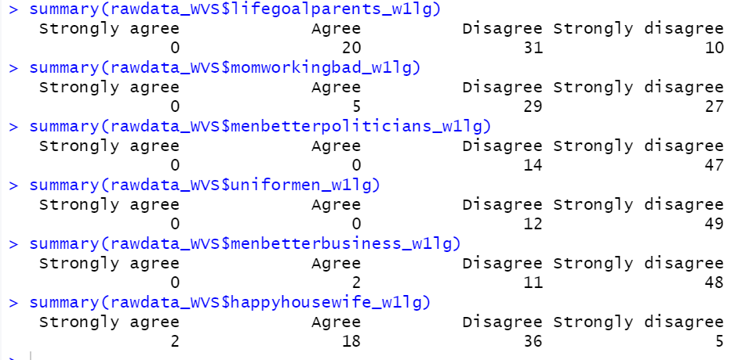

* No missing values
* Still to do: Indices have to be built

1. **Q46 free choice vs. no choice: nochoicevschoice_w1lg**

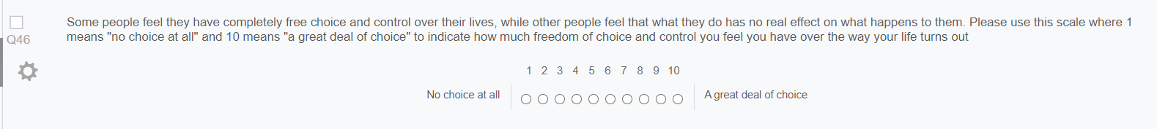

* **nochoicevschoice_w1lg**

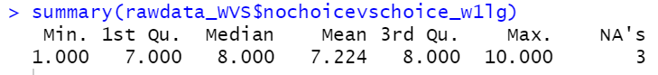

* 3 missing values: 11, 12, 13
* Still to do: what to do with the missing values

1. **Q47 people take advantage:**

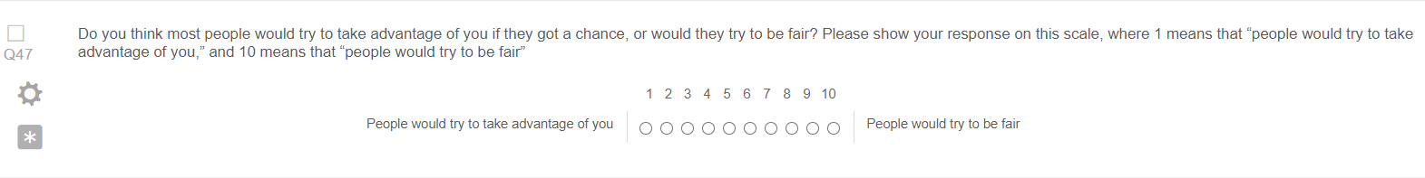

* unfairvsfair_w1lg

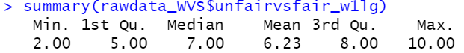

* No missing values

1. **Q50 aims for the country**

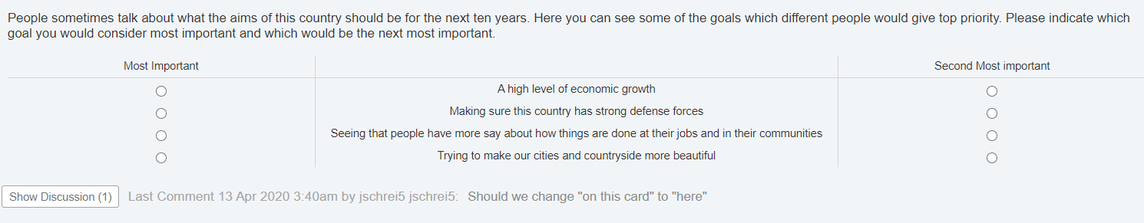

* 4 variables: countryaimgrowth_w1lg, countryaimmilitary_w1lg, countryaimparticipation_w1lg, countryaimbeauty_w1lg

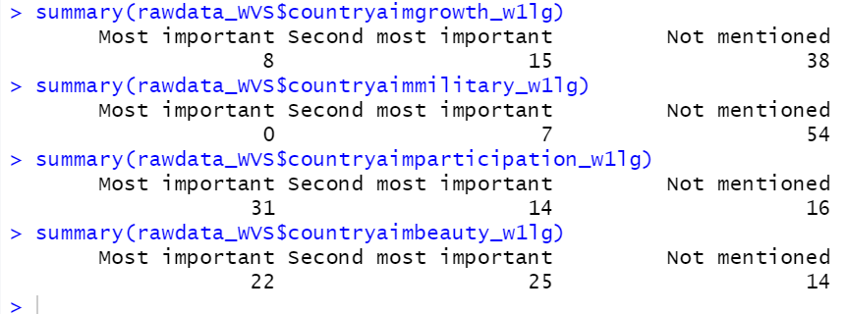

(every time an aim was not mentioned as most or second most important, a missing value was assigned to the variable, I changed the missing values into a 3rd level: not mentioned)

* In the WVS dataset the 4 variables were combined into 2 variables:
  + Aims of country: first choice

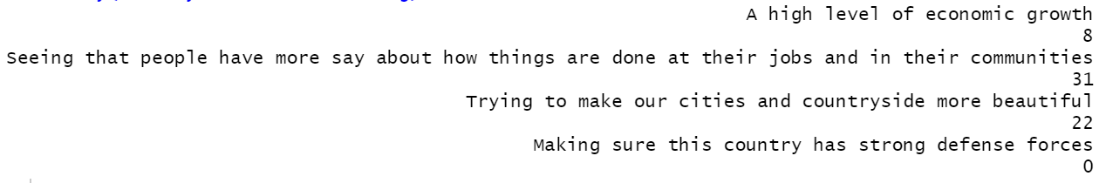

* + Aims of country: second choice

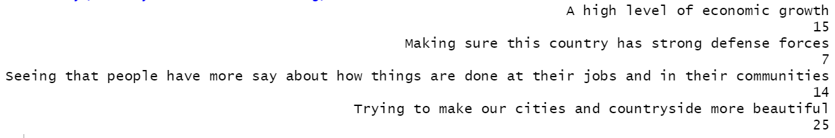

1. **Q53 important things**

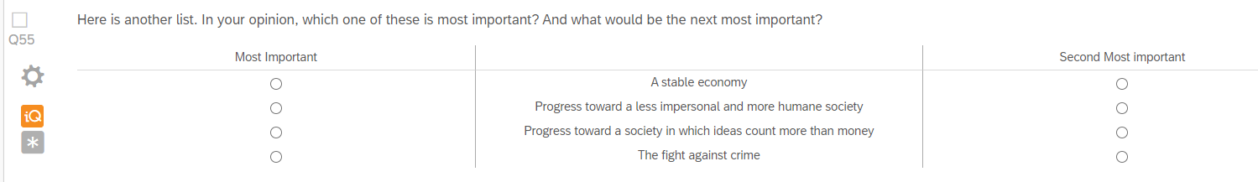

* 4 variables: impoeconomy_w1lg, impojustsociety_w1lg, impoideasociety_w1lg, imponocrime_w1lg

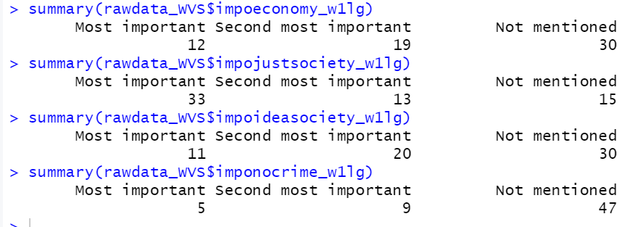

* In the WVS dataset the 4 variables were combined into 2 variables:
  + Most important: First choice

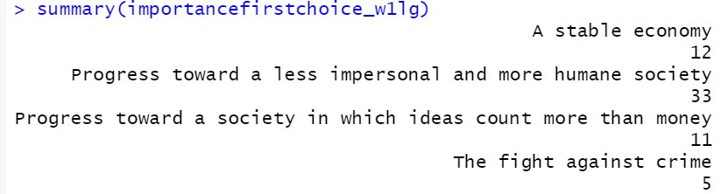

* + Most important: Second choice

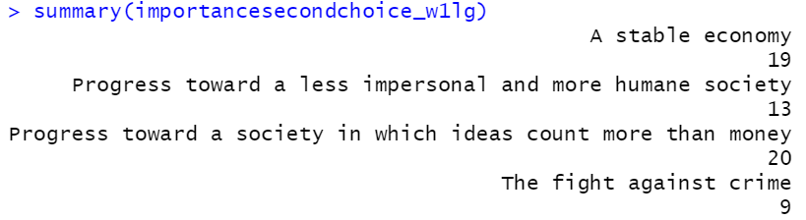

1. **Q55 Participant aims**

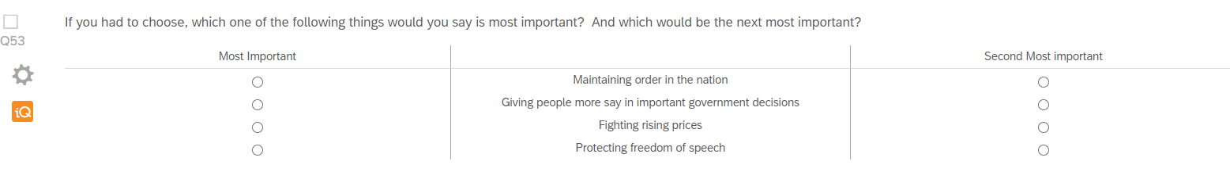

* 4 variables: impolaworder_w1lg, impomoresay_w1lg, impolowprices_w1lg, impofreespeech_w1lg

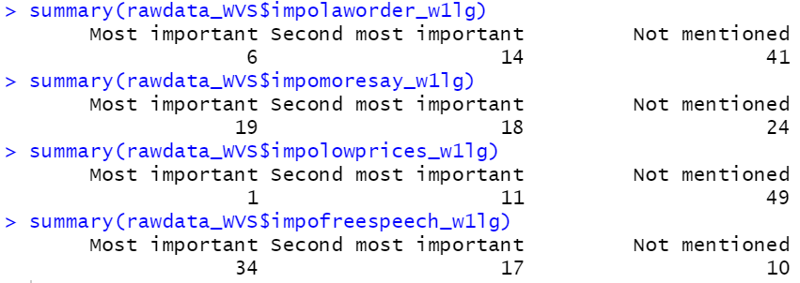

* No missing values
* In the WVS dataset the 4 variables were combined into 2 variables
  + Aim of respondent: First choice

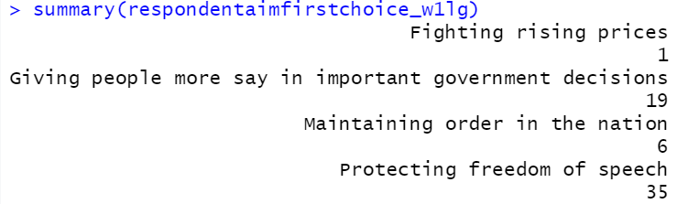

* + Aim of respondent: Second choice

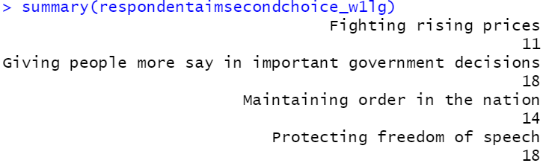

1. **Q181 – Political priorities**

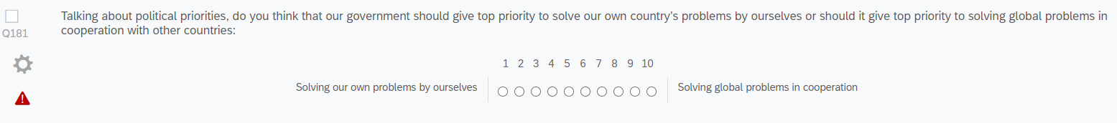

* Countryegovsaltru_w1lg

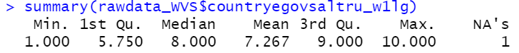

* 3 missing values: 11, 12, 13

1. **Q56 – Future changes**

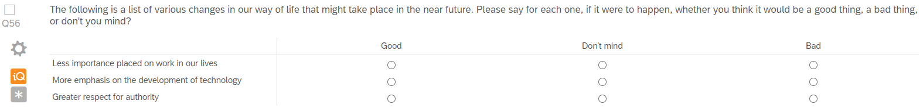

* 3 variables: lessworkgoodbad_w1lg, moretechgoodbad_w1lg, moreauthoritygoodbad_w1lg

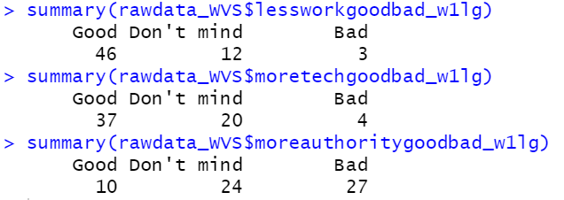

* No missing values

1. **Q57 – Portraits Value Questionnaire**

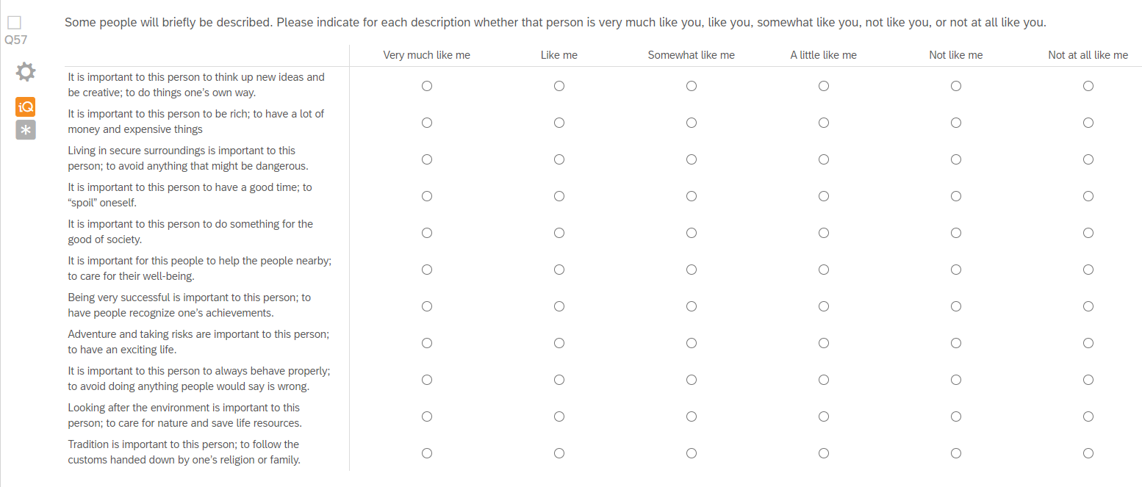

* 11 variables: pvqselfdirection_w1lg, pvqpower_w1lg, pvqsecurity_w1lg, pvqhedonism_w1lg, pvqbenevolence_w1lg , pvqachievement_w1lg, pvqstimulation_w1lg, pvqconformity_w1lg, pvquniversalismsoc_w1lg, pvquniversalismenv_w1lg, pvqtradition_w1lg

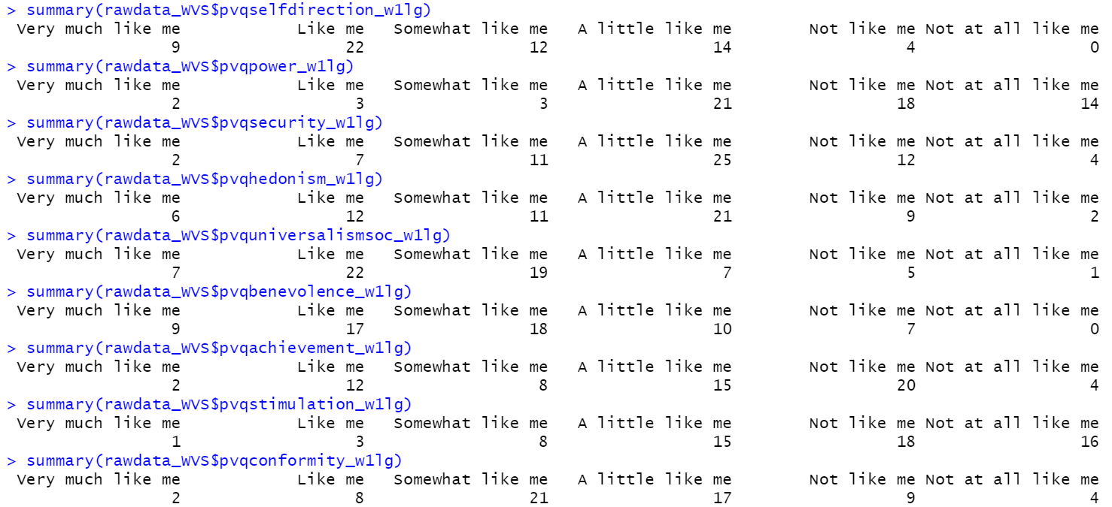

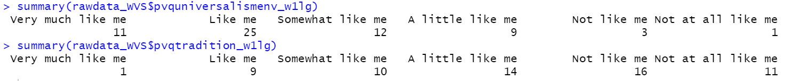

* No missing values
* Still to do: build index

1. Q59 – Protecting environment vs. economic growth



* Ecovsgrowth_w1lg



* No missing values

1. **Q60 - Activities in past two years**

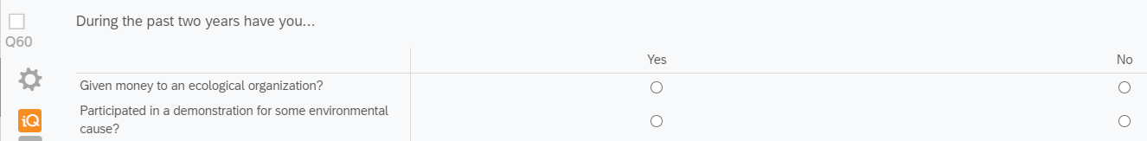

* 2 variables: moneytoeco_w1lg, demoforeco_w1lg

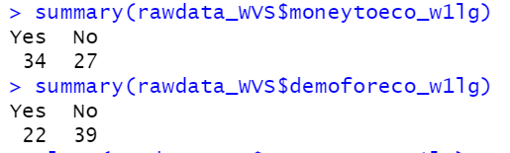

* No missing values

1. **Q62 – Activism**

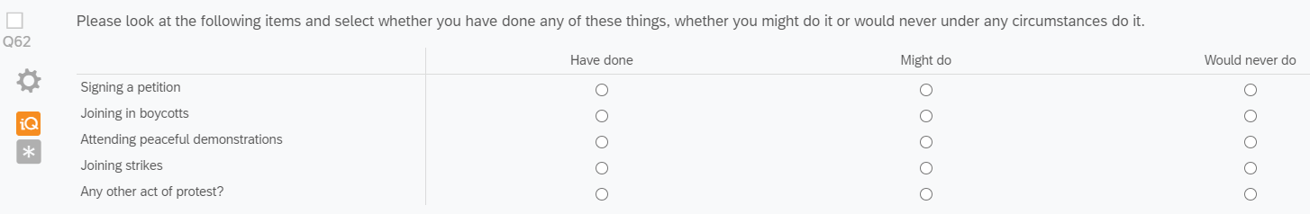

* 5 variables: activismpetition_w1lg, activismboycott_w1lg, activismdemo_w1lg, activismstrike_w1lg, activismotherprotest_w1lg

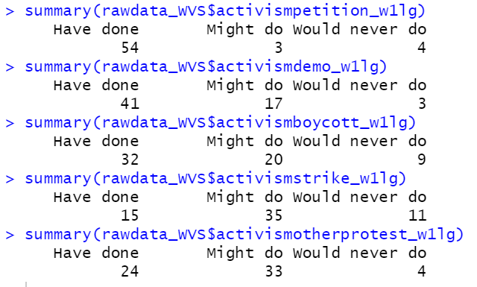

* No missing values

1. **Q65 Political orientation**

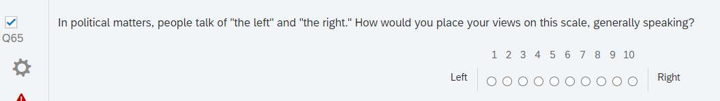

* Leftright_w1lg

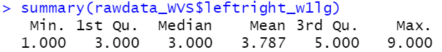

* No missing values

1. **Q70 Trusting people**

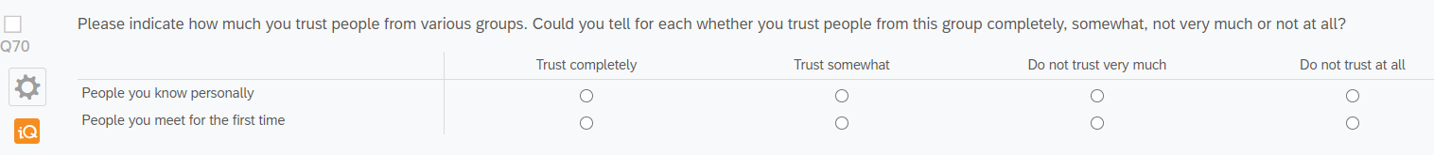

* 2 variables: trustknownpeople_w1lg, trustmetpeople_w1lg

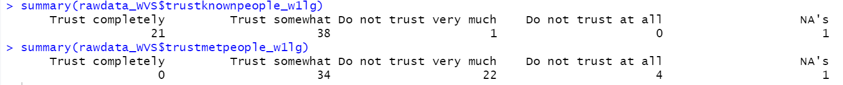

* 1 missing value each: 50
* Still to do: What to do with the missing value

1. **Q73 Trusting organizations**

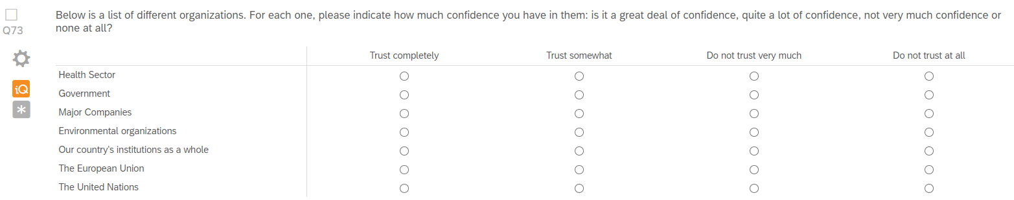

* 7 variables: confhealthsector_w1lg, confgovernment_w1lg, confcompanies_w1lg, confecoorga_w1lg, confcountry_w1lg, confeu_w1lg, confun_w1lg

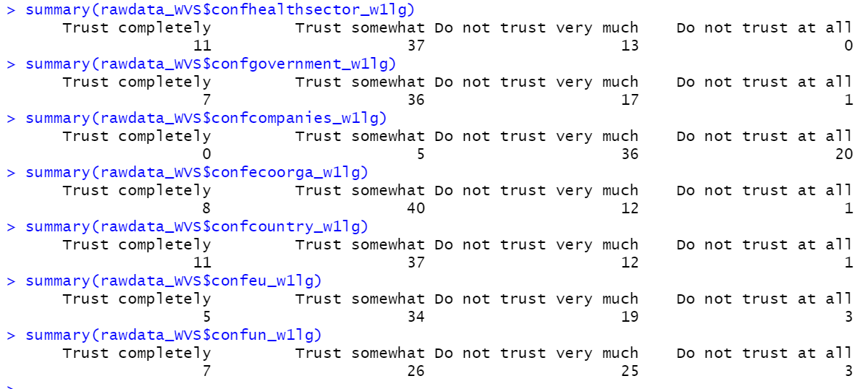

* No missing values

1. **Q79 Democracy in country**



* Undemocraticvsdemocratic_w1lg

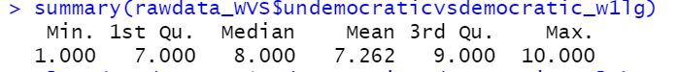

* No missing values

1. **Q78 Respect for human rights in country**

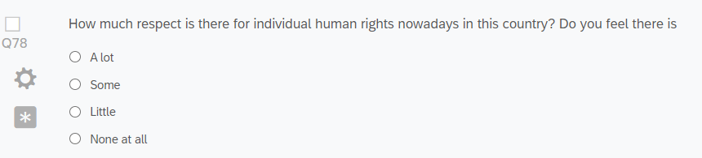

* Respecthumanrights_w1lg

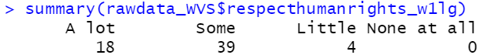

* No missing values

1. **Q81 Attending religious services**



* Religousevents_w1lg



* No missing values

1. **Q83 Religiousness**

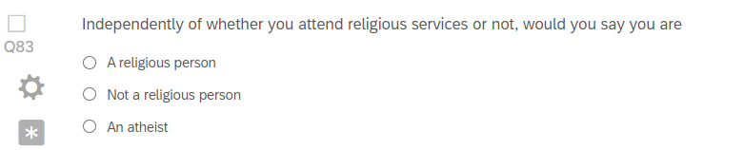

* Religious_w1lg



* No missing values

1. **Q89: Importance of God**

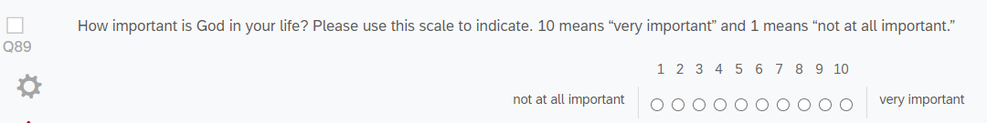

* Importancegod_w1lg

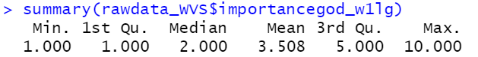

* No missing values

1. **Q97: Perceptions of self**

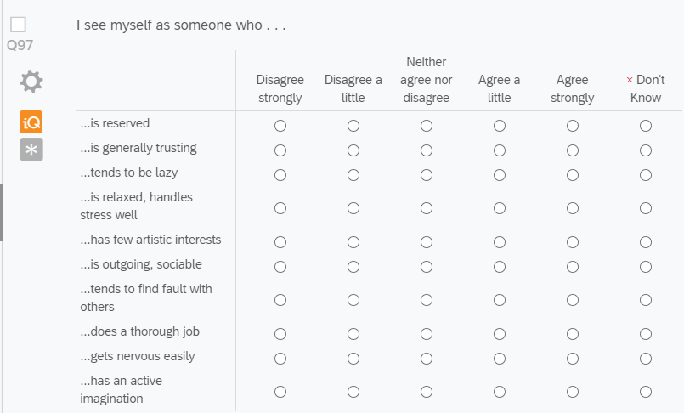

* 10 variables: imreserved_w1lg, imtrusting_w1lg, imlazy_w1lg, imrelaxed_w1lg, imnoartist_w1lg, imsociable_w1lg, impicky_w1lg, imthourough_w1lg, imnervous_w1lg, imimaginative_w1lg

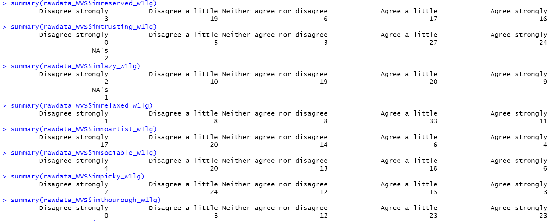



* Imtrusting_w1lg: 2 missing values – observations 3, 29
* Imlazy_w1lg: 1 missing value – observation 23
* Still to do: build indices, decide what to do with missing values

1. **Q101: Necessity of war for justice**

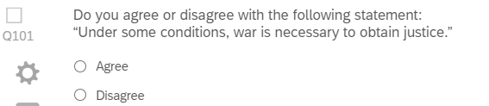

* Warjustified_w1lg

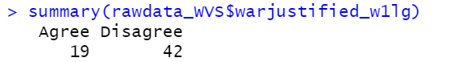

* No missing values

1. **Q112 – importance of science in daily life**

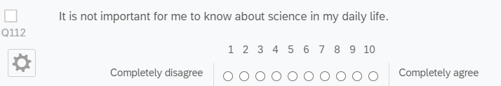

* Sciencenotrelevant_w1lg

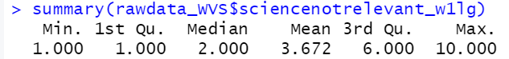

* No missing values

1. **Q108 – Healthier, easier and more comfortable lives through technology**

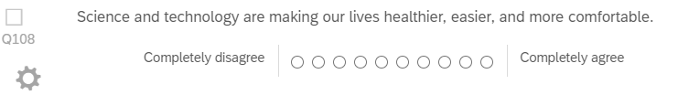

* Sciencemakeseasy_w1lg

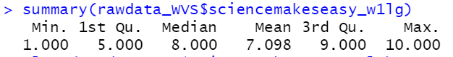

* No missing values

1. **Q116 – Own perception of relation to the world**

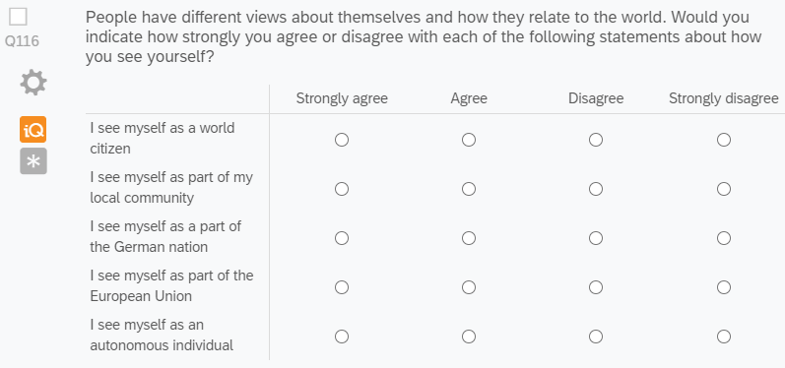

* 5 variables: imworldcitizen_w1lg, imlocal_w1lg, imgerman_w1lg, imeuropean_w1lg, imautonomous_w1lg

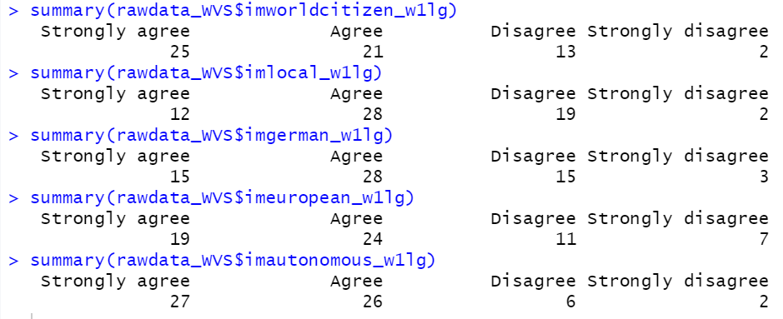

* No missing values
* Still to do: build indices

1. **Q138 – quality of living in own city**

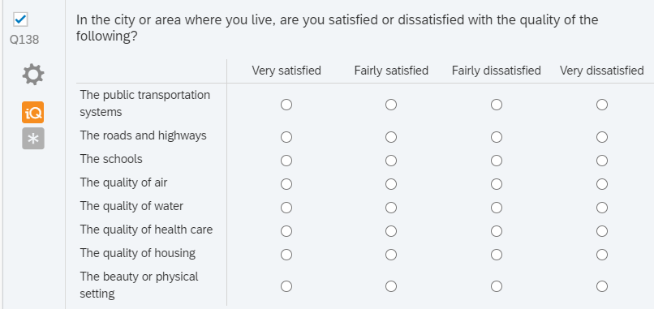

* 8 variables: satpublictransport_w1lg, satroads_w1lg, satschools_w1lg, satair_w1lg, satwater_w1lg, sathealthcare_w1lg, sathousing_w1lg, satsetting_w1lg

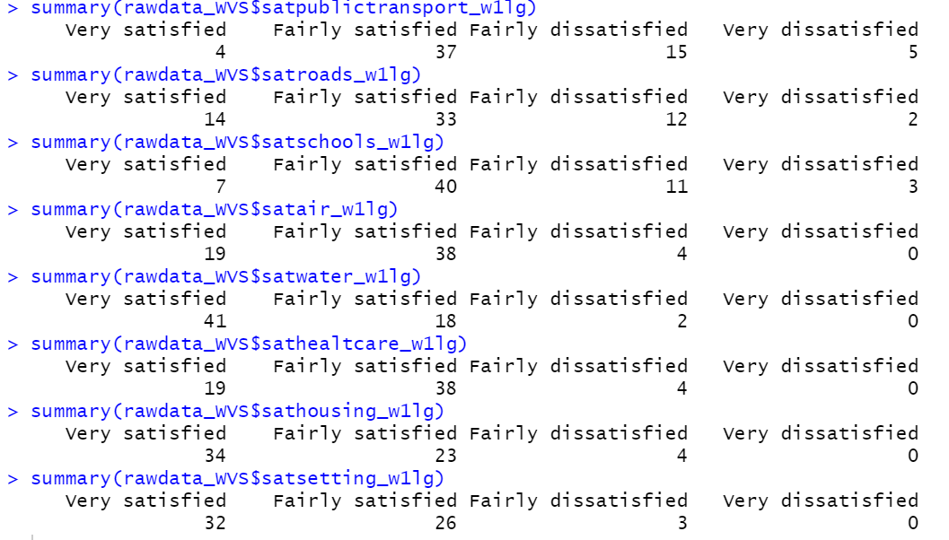

* No missing values
* Still to do: Build indices